EASTERN INTERNATIONAL UNIVERSITY  SCHOOL OF COMPUTING AND INFORMATION TECHNOLOGY   | Practice Assignment – Quarter …, 20…-20…  Course Name: Backend Development  Course Code: CSW 306  Student’s Full Name:  Student ID:
Practice Assignment 4

LIBRARY MANAGEMENT SYSTEM
Following Practice Assignment 3, further develop the new model in the .Net Core framework.
------------------------------------------------------------------------------------------------------------
Exercise 1:
Design a database using SQL Server and migrate it to the model in the project with the tables listed below.
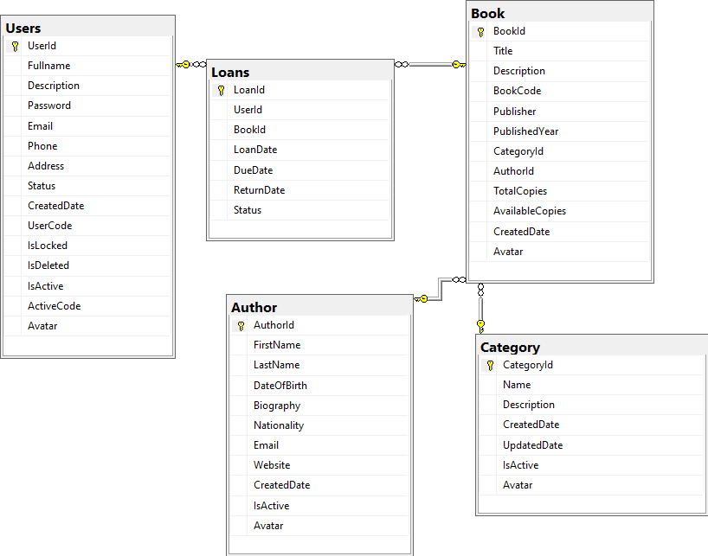
Figure 2: Diagram of the library management database

Users:
User
# | Col_Name | Data Type | Descriptions
1 | UserId | int
  Unique identifier for each user, auto-incremented.
2 | Fullname | nvarchar(200)
  Full name of the user.
3 | Description | nvarchar(MAX) | Additional info about the user, like interests or bio.
4 | Password | nvarchar(MAX) | Hashed password for secure authentication.
5 | Email | nvarchar(100) | User's email address, used for communication and verification.
6 | Phone | nvarchar(20) | User's contact phone number.
7 | Address | nvarchar(MAX) | User's physical address for mailing or location purposes.
8 | Status | int | Represents the user's status.
9 | CreatedDate | datetime | Date and time when the user account was created.
10 | UserCode | nvarchar(MAX) | Unique code for internal identification of the user.
11 | IsLocked | bit | Indicates if the account is locked (1) or active (0).
12 | IsDeleted | bit | Marks the account as deleted (1) or active (0) for soft deletion.
13 | IsActive | bit | Shows if the account is active (1) or inactive (0).
14 | ActiveCode | nvarchar(MAX) | Code for account activation, sent via email during registration.
15 | Avatar | nvarchar(MAX) | Avatar’s User - Local location in the server to get the picture.
Loans:
Loans
# | Col_Name | Data Type | Descriptions
1 | LoanId | int | (Primary Key, Auto-Increment)
2 | UserId | int | References the user who borrowed the book.
3 | BookId | int | References to the borrowed book.
4 | LoanDate | datetime | Date when the book was borrowed.
5 | DueDate | datetime | Date when the book is due.
6 | ReturnDate | datetime | Date when the book was returned.
7 | Status | int | Status of the loan (e.g., "Active", "Returned", "Overdue"). 0: Active , 1: Returned , 2: Overdue
Books:
Books
# | Col_Name | Data Type | Descriptions
1 | BookId | int | (Primary Key, Auto-Increment)
2 | Title | nvarchar(200) | Title of the book.
3 | Description | nvarchar(MAX) | Description of the book.
4 | BookCode | nvarchar(MAX) | Standard Book Number.
5 | Publisher | nvarchar(MAX)
6 | PublishedYear | datetime | The year the book was published.
7 | CategoryId | int | References to the category.
8 | AuthorId | int | References the author.
9 | TotalCopies | int | Total number of physical copies of the book in the library
10 | AvailableCopies | int | Total number of physical copies of the book currently in the library, excluding copies on loan
11 | CreatedDate | datetime | Date when the book record was created.
12 | Avatar | nvarchar(MAX) | Cover image of the book - Local location in the server to get the picture.
13 | Pdf | nvarchar(MAX) | Store the version pdf for reading online
Authors:
Authors
# | Col_Name | Data Type | Descriptions
1 | AuthorId | int | (Primary Key, Auto-Increment). Unique identifier for each author.
2 | FirstName | nvarchar(100) | Author's first name.
3 | LastName | nvarchar(100) | Author's last name.
4 | DateOfBirth | datetime | Author's date of birth.
5 | Biography | nvarchar(MAX) | A short biography of the author.
6 | Nationality | nvarchar(100) | Nationality of the author.
7 | Email | nvarchar(100) | Author's Email.
8 | Website | nvarchar(100) | Author's Website.
9 | CreatedDate | datetime | Date when the author record was created.
10 | IsActive | bit | The IsActive column helps indicate whether a record is currently active and usable within the application.
11 | Avatar | nvarchar(MAX) | Authors’ Avatar - Local location in the server to get the picture.
Categories:
Categories
# | Col_Name | Data Type | Descriptions
1 | CategoryId | int | Unique identifier for each category (Primary Key).
2 | Name | Nvarchar (MAX) | Name of the category; must be unique for identification.
3 | Description | Nvarchar (MAX) | Additional information about the category.
4 | CreatedDate | datetime | Date and time when the category was created.
5 | UpdatedDate | datetime | Date and time when the category was last updated.
6 | IsActive | bit | Indicates if the category is active (1) or inactive (0).
7 | Avatar | Nvarchar (MAX) | Category's image - Local location in the server to get the picture.
Note:
Use Data Annotations for Validation:
- Implement data annotations such as [Required], [StringLength], [EmailAddress], etc., to enforce validation rules on model properties.
- Ensure that validation attributes reflect business rules and requirements.
Implement Navigation Properties:
- Define relationships between models using navigation properties (e.g., one-to-many, many-to-many).
- Use collections to represent related entities (e.g., ICollection<Product> in a Category model).
Create a DbContext Class:
- Define a DbContext class that represents the session with the database.
- Include DbSet<T> properties for each model to facilitate data access.
Exercise 2:
Add a new database table named Carousel and implement the corresponding model in your backend project to support displaying images or promotional content on the homepage of your Library Management System. The data should be retrieved dynamically from the database through APIs.
Purpose:
- Provide backend support for managing and serving carousel items (such as images and promotional content) displayed on the homepage.
Fields:
- CarouselId: int (Primary Key)
- ImageUrl: nvarchar(MAX) (Required) - URL of the image.
- Title: nvarchar(200) (Required) - Title for the item.
- Description: nvarchar(MAX) (Optional) - Additional details.
- LinkUrl: nvarchar(MAX) (Optional) - URL linked to the item.
- Order: int (Required) - Display order of items.
- IsActive: bit - Indicates if the item is active.
- CreatedDate: datetime - Timestamp of creation.
- UpdatedDate: datetime - Timestamp of last update.
Guide:
To serve image files from the server in your .NET Core 8.0 project, you can configure your application to serve static files from a specific directory on the server. Here’s how to set it up:

Step 1: Store Images in a Server Directory
- Decide on a directory where you’ll store the images for the carousel. For example, let’s use a folder named carousel_images inside the wwwroot folder of your project (e.g., wwwroot/carousel_images).
- Place your image files in this directory.
* You can set it anywhere in the server if you want to store the image.

Step 2: Configure Static Files in Startup or Program.cs
In ASP.NET Core 8.0, static files are served by default from the wwwroot folder. You just need to make sure the UseStaticFiles middleware is added to your pipeline, which is typically already included.
In your Program.cs, you should have:
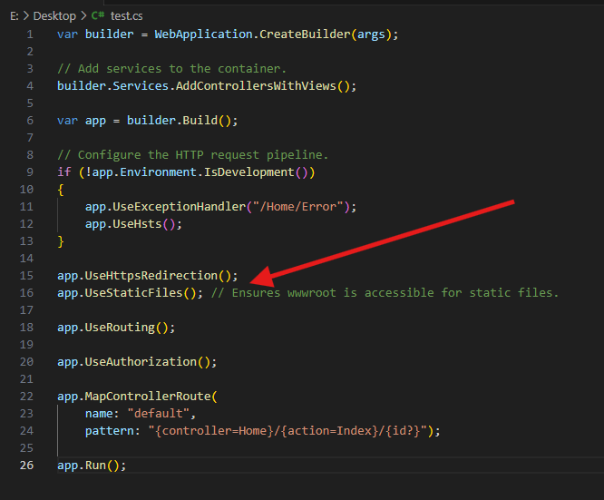

Step 3: Use Relative Paths in the Model
Store relative paths like /carousel_images/banner1.jpg in the ImageUrl property. This keeps URLs portable and easy to construct on the client side.

Step 4: Create API Endpoints
Build Web API endpoints to support operations such as:
- GET /api/carousel – Fetch all (or only active) carousel items.
- GET /api/carousel/{id}- Get carousel item by Id
- POST /api/carousel – Add a new carousel item.
- PUT /api/carousel/{id} – Update an existing item.
- DELETE /api/carousel/{id} – Remove an item. ( Deleted both of database and file in server )
These APIs allow client applications (web/mobile) to retrieve and manage carousel content dynamically.

Step 5: Image Access via URL
When you run your application, ASP.NET Core will serve images directly from the wwwroot directory. So if your ImageUrl is /carousel_images/image1.jpg, it will be resolved to https://yourdomain.com/carousel_images/image1.jpg.
Make sure the ImageUrl field correctly maps to this path.
Exercise 3: Implement Full CRUD for Books
Objective: Create complete CRUD API endpoints for the Books table.
Requirements:
- GET: Retrieve a list of books with pagination, search by title, and filtering by CategoryId or AuthorId.
- GET /api/books/{id} – Get book details by ID.
- POST: Add a new book (including uploading a cover image and PDF file).
- PUT: Update existing book information.
- DELETE: Soft delete (by updating IsActive or IsDeleted instead of removing from database – add these fields if not available in the model and database).
Exercise 4: Author Management
Objective: Manage Authors data.
Requirements:
- GET /api/authors: List all authors with optional search by name.
- GET /api/authors/{id}: Get author details.
- POST, PUT, DELETE: Create, update, and soft delete authors.
- Allow uploading of avatar images and store relative paths.
Exercise 5: Loan History Management
Objective: Display and manage book loan records.
Requirements:
- GET /api/loans: Filter by UserId, Status, or loan date range.
- GET /api/loans/{id}: View loan details.
- POST: Create new loan record (only if AvailableCopies > 0).
- PUT: Update return date and automatically set Status to Returned.
Exercise 6: User Registration & Login
Objective: Implement user APIs.
Requirements:
- POST /api/users/register: Register new users (hash password, generate ActiveCode, and simulate sending activation email).
- GET /api/users/activate?code=xxx: Activate account via activation code.( Optional – add a new method using POST and body json to Activate account via activation code)
Exercise 7: Category Management with Activation
Objective: Manage book categories and enable/disable them.
Requirements:
- GET /api/categories: Filter by IsActive and search by name.
- POST / PUT: Add or update category.
- PATCH /api/categories/{id}/toggle: Toggle the IsActive status of a category.
Exercise 8: Top Borrowed Books Report
Objective: Generate a report of the most borrowed books.
Requirements:
- GET /api/reports/top-borrowed?fromDate=...&toDate=...&top=10
Return list of BookId, Title, and number of times borrowed within the given time range.
Exercise 9: PDF Online Reader
Objective: Allow users to read book PDFs online.
Requirements:
- Create endpoint GET /api/books/{id}/read
Check if the book has a PDF file → return a relative URL. If not, a message is not found.
- Allow the client to embed the PDF using <iframe> or a PDF reader component.
Exercise 10: Soft Delete & Recycle Bin for Books
Objective: Manage soft-deleted books and support recovery.
Requirements:
- GET /api/books/deleted: List books where IsDeleted = true.
- PATCH /api/books/{id}/restore: Restore a previously deleted book.
- DELETE /api/books/{id}/hard: Permanently delete a book and its associated files (PDF and image) from the server.

